**Bangladesh University of Business and Technology**

**(BUBT)**



**Project Report**

Project Name : Online Banking System

Course Title : Software Development 1

Course Code : CSE 100

Supervised By:

Sudipto Chaki

Course Instructor

Department of CSE

Bangladesh University of Business and Technology (BUBT)

|  |  |  |  |
| --- | --- | --- | --- |
| **Submitted By** | | | |
|  |  |  |  |
| Name | ID | Intake | Section |
| Md. Mehedi Hasan | 21225103334 | 49 | 08 |
| Mushfiqur Rahman Pulok | 21225103525 | 49 | 08 |
| Mehedi Hasan Pranto | 21225103357 | 49 | 08 |
| Md Istihad Tamim | 21225103318 | 49 | 08 |
| Sirin akter | 21225103542 | 49 | 08 |
| **GROUP:02** | | | |
|  |  |  |  |

**ABSTRACT**

With the arrival of the age of the internet, the financial service community is provided with tremendous opportunities and challenges. Online Banking Services are accessible to all the customer who have their valid user and id allocated by the them. Online Banking System has attracted the attentions of banks, securities, insurance companies in developing nations since the 1990s and the rapid and significant growth in electronic sectors and commerce. Today’s providers must consider the Internet and on-line services besides their traditional non-online services. In this report, the analysis, design and implementation details of an on-Line banking application have been described.

**Dedication**

“If you had started doing anything two weeks ago, by today you would have been two weeks better at it.”

― **John Mayer**

Dedicated to our parents, teachers, friends, relatives and all who loved us for all their love and inspirations.

**APPROVAL**

The report is “Online Banking System”. This report is submitted by Md. Mehedi Hasan (21225103334), Mushfiqur Rahman Pulok (21225103525), Mehedi Hasan Pranto (21225103357), Md Istihad Tamim (21225103318), Sirin Akter (21225103542), Department of Computer Science and Engineering, Bangladesh University of Business and Technology under the supervision of Sudipto Chaki, Course Instructor, Department of Computer Science and Engineering has been accepted as satisfactory for the partial fulfillment of the requirements for the degree of Bachelor of Science (B.Sc. Engg.) in Computer Science and Engineering.

**Supervisor:**

Sudipto Chaki

Course Instructor

Department of CSE

Bangladesh University of Business and Technology (BUBT)

**Chairman:**

**Md. Saifur Rahman**

**Associate Professor & Chairman,**

Department of CSE

Bangladesh University of Business and Technology (BUBT)

**CONTENTS**

**Chapter- 1: Introduction**

1.1 Project Aim & Objective.................................................... 07

1.2 Operation Environment.....................................................08

**Chapter- 2: System Analysis**

2.1 System Requirement & Specification................................09

2.2 Existing VS Proposed..........................................................10

2.3 Software Tools Used...........................................................11

**Chapter- 3: System Design**

3.1 Flowchart........................................................................... 12

**Chapter- 4: System Implementation**

4.1 Module Description............................................................13

4.2 Coding Analysis ..................................................................14-24

4.3 Screenshots........................................................................ 25-31

**Chapter- 5: Conclusion**

5.1 Limitations.......................................................................... 32

5.2 Future Work ...................................................................... 33

5.3 Conclusion.......................................................................... 34

Chapter- 1: Introduction

* 1. **Project Aim & Objective**

The main objective of the project is to develop online Banking system for banks. In present system some banks are working software based but most banks are doing it manually. User have to visit bank to Withdrawal or Deposit amount. In present bank system it is also difficult to find account information of account holder. In this bank management system, we will automate all the banking process. In our bank management system user can check his balance online and he can also transfer money to other account online. In this Software you can keep record for daily Banking transactions. The main purpose of developing bank management system is to design an application, which could store bank data and provide an interface for retrieving customer related details with 100% accuracy.

**1.2 Operation Environment**

**Programming Language:**

**◼ C Programming Language**

**Compiler:**

**◼ GCC (MingW / GNU GCC)**

**Debugger:**

**◼ Interfaces GNU GDB**

Chapter- 2: System Analysis

**2.1 System Requirement & Specification**

**◼ Ram:**

**Minimum: 512 MB**

**Recommended: 1 GB to above**

**◼ Windows:**

**Minimum: Windows XP**

**Recommended: Windows 7 to above**

**◼ Processor:**

**Minimum: 1 GHz**

**Recommended: 2 GHz or more**

**2.2 Existing VS Proposed**

**Proposed features:**

* Registration/ login
* Check balance
* Fund deposit
* Fund withdrawal
* Online fund transfer
* Pay bill
* Mobile recharge
* Changing password of online banking account
* Check the details of an existing account
* Update the details of an existing account

**Existing features:**

* Registration
* login
* Check balance
* Fund deposit
* Fund withdrawal
* Online fund transfer
* Changing password of online banking account
* Check the details of an existing account
* Update the details of an existing account

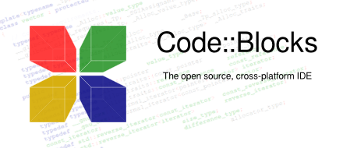**2.3 Software Tools Used**

**Code::Blocks:**

Code::Blocks is a free, open-source cross-platform IDE that supports

multiple compilers including GCC, Clang and Visual C++. It is

developed in C++ using widgets as the GUI toolkit. Using a plugin

architecture, its capabilities and features are defined by the provided

plugins. Currently, Code::Blocks is oriented towards C, C++, and

Fortran. It has a custom build system and optional Make support.

Code::Blocks is being developed for Windows and Linux and has been

ported to FreeBSD, OpenBSD and Solaris.

Chapter- 3: System Design

**3.1 Flowchart:**

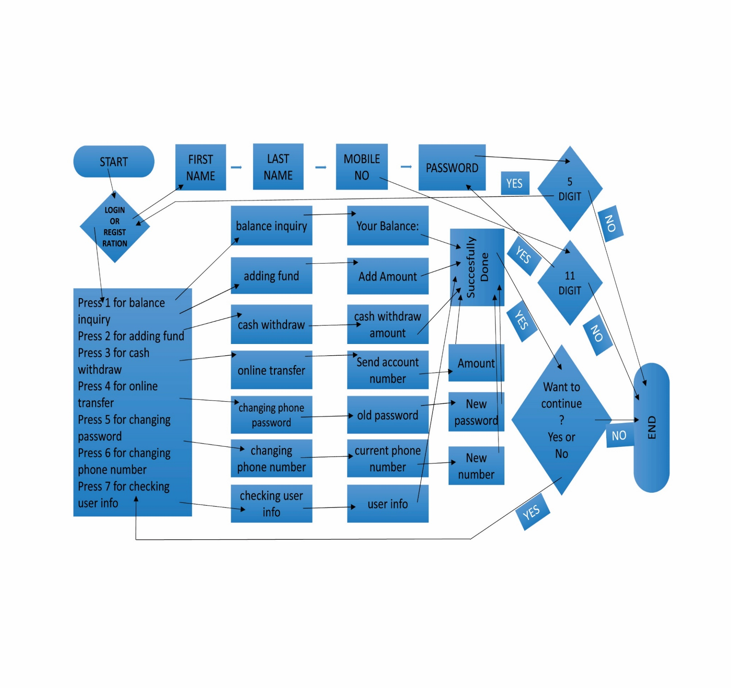

Chapter- 4: System Implementation

**4.1 Module Description**

1. Registration/Login:

In this feature User can create an account by themselves. After registration complete they can access their account.

1. Check Balance:

In this feature User can check their account balance.

1. Fund Deposit:

In this feature User can add their money into account.

1. Fund Withdrawal:

In this feature User can withdraw their money from their account.

1. Online fund Transfer:

In this feature User can send money via online to other user account.

1. Changing password of online banking account

In this feature user can change their online bank account password anytime if they want.

1. Changing phone number:

In this feature user can change their number. Thus phone number is their main account number for use of online banking system.

1. Check the details of an existing account:

In this feature user can see their account details.

4.2 Coding Analysis

#include<stdio.h>

#include<conio.h>

#include<string.h>

#include<math.h>

#include<dos.h>

#include<time.h>

#include<ctype.h>

#include<windows.h>

#include<string.h>

#include<time.h>

#define ENTER 13

#define BKSP 8

#define SPACE 32

#define TAB 9

#define CNN 15

#define CBN 4

struct user {

char phone[50];

char name[50];

char name1[50];

char password[50];

float balance;

};

COORD coordinates = {0,0};

void gotocoordinate(int x,int y)

{

coordinates.X=x;

coordinates.Y=y;

SetConsoleCursorPosition(GetStdHandle(STD_OUTPUT_HANDLE),coordinates);

}

COORD coord = {0, 0};

void gotoxy(int x, int y)

{

COORD coord;

coord.X = x;

coord.Y = y;

SetConsoleCursorPosition(GetStdHandle(STD_OUTPUT_HANDLE), coord);

}

void setcolor(int ForgC)

{

WORD wColor;

HANDLE hStdOut=GetStdHandle(STD_OUTPUT_HANDLE);

CONSOLE_SCREEN_BUFFER_INFO csbi;

if(GetConsoleScreenBufferInfo(hStdOut,&csbi))

{

wColor=(csbi.wAttributes & 0xF0)+(ForgC & 0x0F);

SetConsoleTextAttribute(hStdOut,wColor);

}

}

void welcomeMessage()

{

system("cls");

setcolor(1);

printf("\n\n\n\n\n");

printf("\n\t\t **-**-**-**-**-**-**-**-**-**-**-**-**-**-**-**-**-**-**\n");

printf("\n\t\t =-=-=-=-=-=-=-=-=-=-=-=-=-=-=-=-=-=-=-=-=-=-=");

printf("\n\t\t = WELCOME =");

printf("\n\t\t = TO =");

printf("\n\t\t = ONLINE =");

printf("\n\t\t = BANKING =");

printf("\n\t\t = SYSTEM =");

printf("\n\t\t =-=-=-=-=-=-=-=-=-=-=-=-=-=-=-=-=-=-=-=-=-=-=");

printf("\n\n\t\t **-**-**-**-**-**-**-**-**-**-**-**-**-**-**-**-**-**-**\n");

printf("\n\n\n\t\t\t Enter any key to continue.....");

getch();

}

void loading()

{

system("cls");

int r,q;

gotoxy(36,14);

setcolor(1);

printf("LOADING...");

gotoxy(30,15);

for(r=1; r<=10; r++)

{

for(q=1; q<=100000000; q++);

printf("%c",177);

}

system("cls");

}

int main(){

struct user user,usr;

char filename[50],phone[50],password[50],phone2[50];

FILE *fp,*fptr;

int opt,choice;

int amount;

char cont = 'y';

/*color and font size start here*/

system("COLOR F1");

static CONSOLE_FONT_INFOEX fontex;

fontex.cbSize = sizeof(CONSOLE_FONT_INFOEX);

HANDLE hOut = GetStdHandle(STD_OUTPUT_HANDLE);

GetCurrentConsoleFontEx(hOut, 0, &fontex);

fontex.FontWeight = 500;

fontex.dwFontSize.X = 30;

fontex.dwFontSize.Y = 30;

SetCurrentConsoleFontEx(hOut, NULL, &fontex);

/*color and font end here*/

welcomeMessage();

system("cls");

//loading();

system("cls");

printf("\nWhat do you want to do?");

printf("\n\n1.Register your account");

printf("\n2.Login to your account");

printf("\n\nPlease enter your choice:\t");

scanf("%d",&opt);

if(opt == 1){

system("cls"); //clearing the screen

printf("\nEnter your First name:\t");

//gets(user.name);

scanf("%s",user.name);

printf("Enter your Last name:\t");

//gets(user.name);

scanf("%s",user.name1);

printf("Enter your phone number:\t");

scanf("%s",user.phone);

int len=strlen(user.phone);

if(len==11)

{

printf("Enter your new password:\t");

scanf("%s",user.password);

int len1=strlen(user.password);

if(len1==5)

{

user.balance=0;

strcpy(filename,user.phone);

fp=fopen(strcat(filename,".dat"),"w");

fwrite(&user,sizeof(user),1,fp);

if(fwrite != 0)

{

printf("Successfully registered");

}

}

else

{

printf("Your password must be 5 digits\nTry again...\n");

printf("\n\n***Thank you for banking with us***\n\n");

}

}

else

{

printf("Your Phone number must be 11 digits\nTry again...\n");

printf("\n\n***Thank you for banking with us***\n\n");

}

}

else if(opt == 2){

system("cls");

printf("\nPhone No :\t");

scanf("%s",phone);

printf("Password:\t");

scanf("%s",password);

fp = fopen(strcat(phone,".dat"),"r");

if(fp == NULL) printf("Account number not registered");

else {

fread(&user,sizeof(struct user),1,fp);

fclose(fp);

if(!strcmp(password,user.password)){

while(cont == 'y'){

system("cls");

printf("\n\tWelcome %s %s",user.name,user.name1);

printf("\nPress 1 for balance inquiry");

printf("\nPress 2 for adding fund");

printf("\nPress 3 for cash withdraw");

printf("\nPress 4 for online transfer");

printf("\nPress 5 for changing password");

printf("\nPress 6 for changing phone number");

printf("\nPress 7 for checking user info\n\n");

scanf("%d",&choice);

switch(choice){

case 1:

printf("Your current balance is TK. %.2f",user.balance);

break;

case 2:

system("cls");

printf("Enter amount to be added:\t");

scanf("%d",&amount);

user.balance += amount;

fp = fopen(phone,"w");

fwrite(&user,sizeof(struct user),1,fp);

if(fwrite !=0) printf("\n\nYou have deposited TK.%d",amount);

fclose(fp);

break;

case 3:

system("cls");

printf("Enter withdrawal amount:\t");

scanf("%d",&amount);

if(amount<0) printf("\nSorry amount should be Greater than 0");

else if(amount>user.balance) printf("\nSorry insufficient balance");

else {

user.balance -= amount;

fp = fopen(phone,"w");

fwrite(&user,sizeof(struct user),1,fp);

if(fwrite !=0) printf("\n\nYou have withdrawn TK.%d",amount);

fclose(fp);

}

break;

case 4:

printf("Please enter the phone number to transfer balance:\t");

scanf("%s",phone);

printf("Enter the amount to transfer:\t");

scanf("%d",&amount);

if(amount > user.balance) printf("\nSorry insufficient balance");

else {

fptr = fopen(strcat(phone,".dat"),"r");

if(fptr==NULL) printf("Sorry number is not registered");

else {

fread(&usr,sizeof(struct user),1,fptr);

fclose(fptr);

usr.balance += amount;

fptr = fopen(phone,"w");

fwrite(&usr,sizeof(struct user),1,fptr);

if(fwrite != 0){

// printf("ACcount:%s",usr.ac);

// printf("\npassword%s",usr.password);

// printf("\nphone%s",usr.phone);

// printf("\nbalance%f",usr.balance);

printf("Your transfer is completed. You have transfered TK.%d to %s",amount,usr.phone);

fclose(fptr);

user.balance -= amount;

strcpy(filename,user.phone);

fp = fopen(strcat(filename,".dat"),"w");

fwrite(&user,sizeof(struct user),1,fp);

fclose(fp);

}

}

}

break;

case 5:

printf("\n\nPlease enter your old password:\t");

scanf("%s",password);

if(!strcmp(password,user.password)){

printf("\n\nPlease enter your new password:\t");

scanf("%s",password);

strcpy(user.password,password);

strcpy(filename,user.phone);

fp = fopen(strcat(filename,".dat"),"w");

fwrite(&user,sizeof(struct user),1,fp);

fclose(fp);

printf("\nPassword successfully changed");

}else printf("\nSorry your password is wrong");

break;

case 6:

printf("\n\nPlease enter your current phone number:\t");

scanf("%s",phone);

if(!strcmp(phone,user.phone)){

printf("\n\nPlease enter your new phone number:\t");

scanf("%s",phone);

strcpy(user.phone,phone);

strcpy(filename,user.phone);

fp = fopen(strcat(filename,".dat"),"w");

fwrite(&user,sizeof(struct user),1,fp);

fclose(fp);

printf("\nPhone number successfully changed");

}else printf("\nSorry your phone number is wrong");

break;

case 7:

printf("Your name is: %s %s",user.name,user.name1);

printf("\nYour phone number is: %s",user.phone);

printf("\nYour current balance is TK %.2f",user.balance);

default:

break;

}//switch ends here

printf("\n\nDo you want to continue?[y/n]:\t");

scanf("%s",&cont);

}

}

else {

printf("Invalid password");

}

}

printf("\n\n***Thank you for banking with us***\n\n");

}

return 0; }

**4.3 Screenshots**

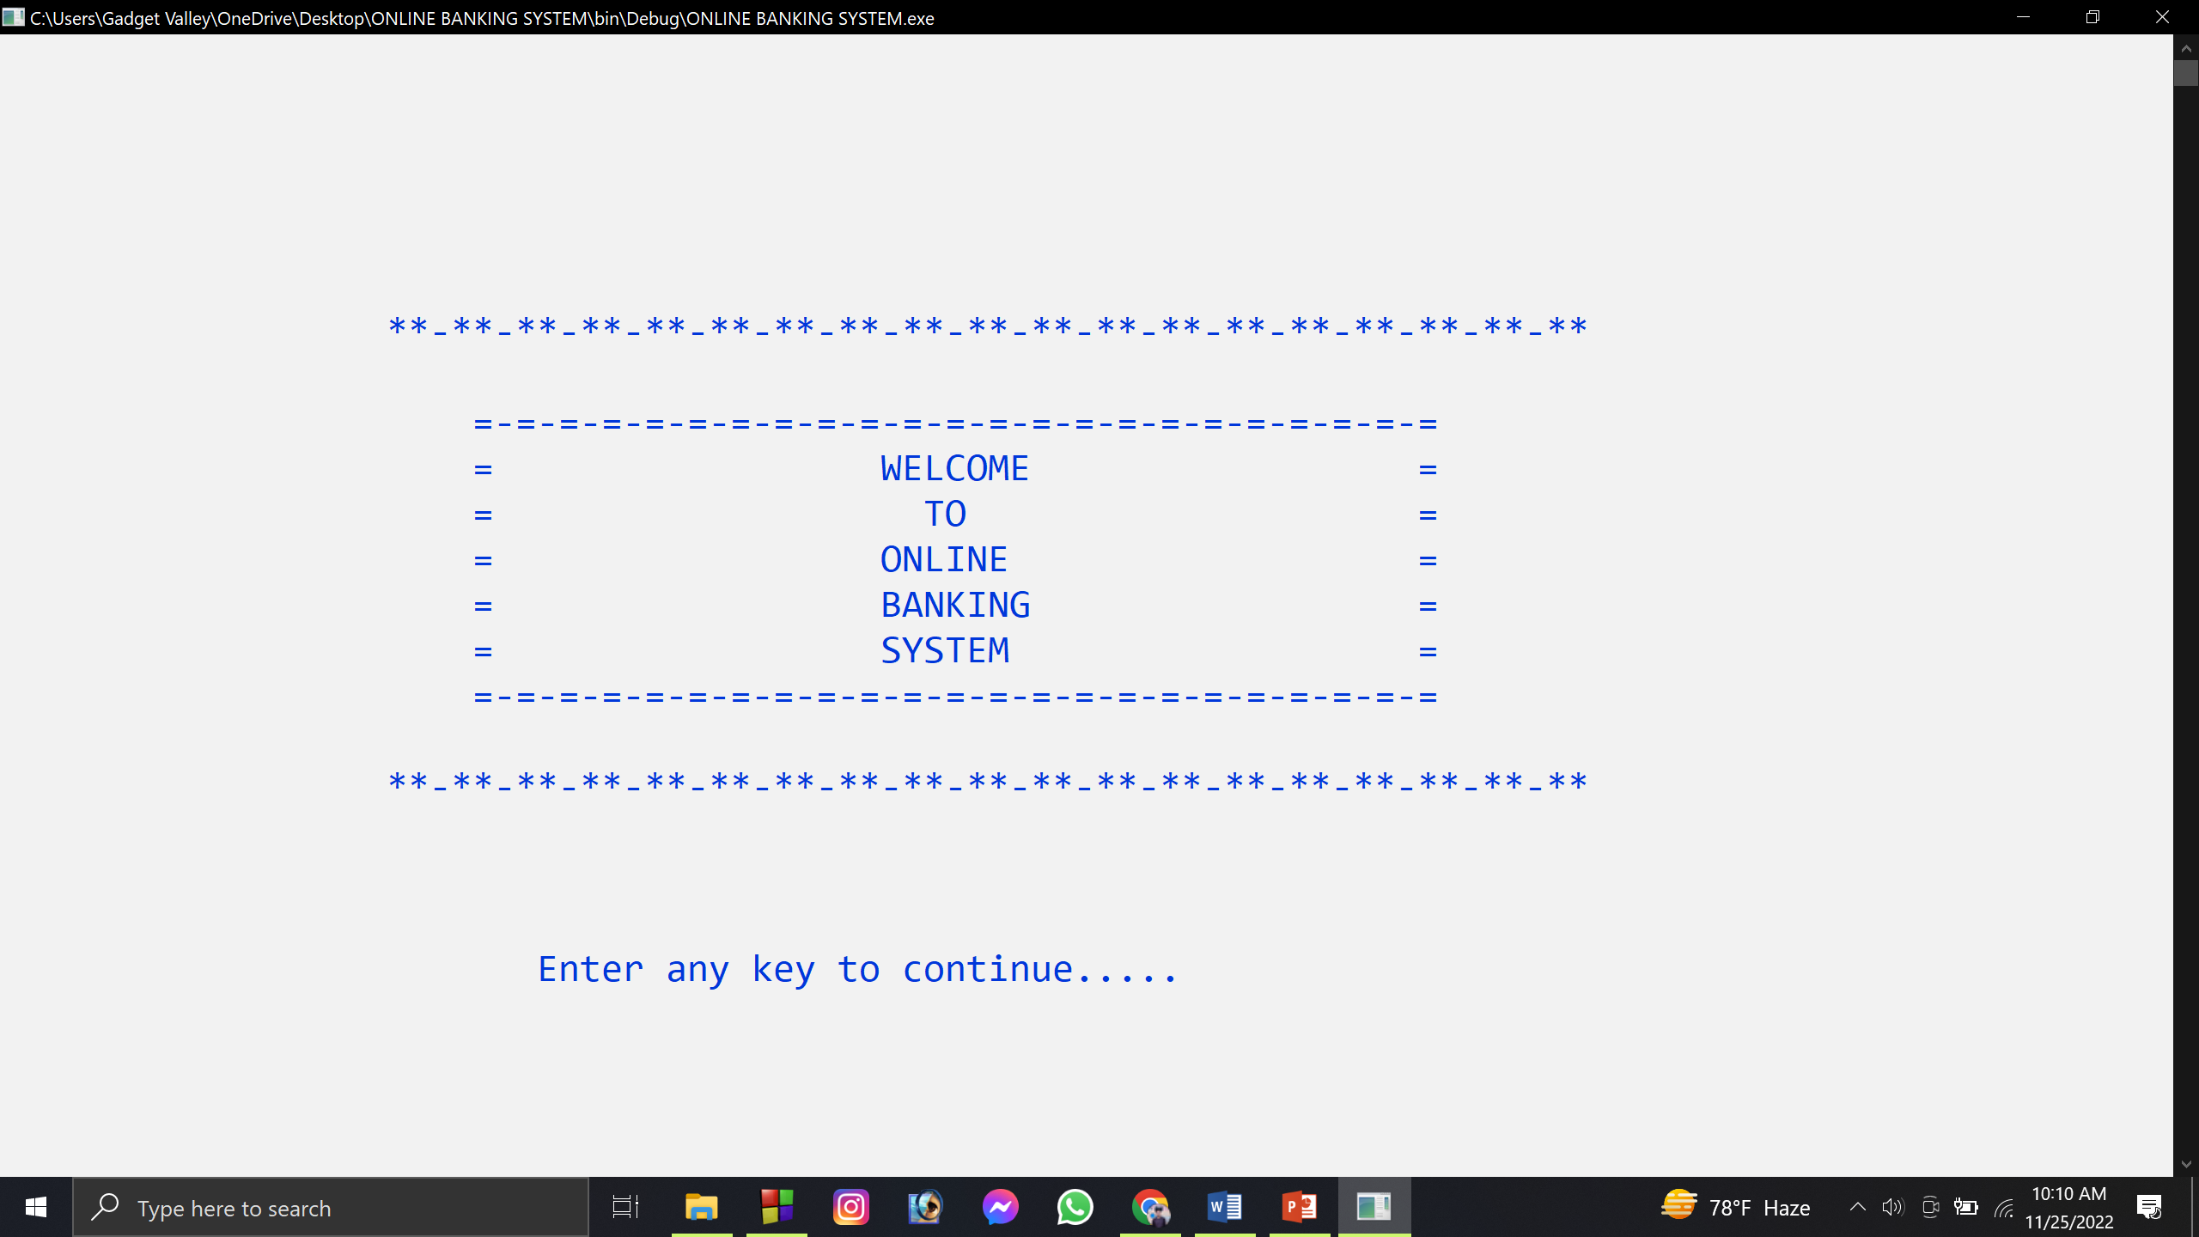

**Fig-1**

**Fig- 1:** This is the opening page of the program.

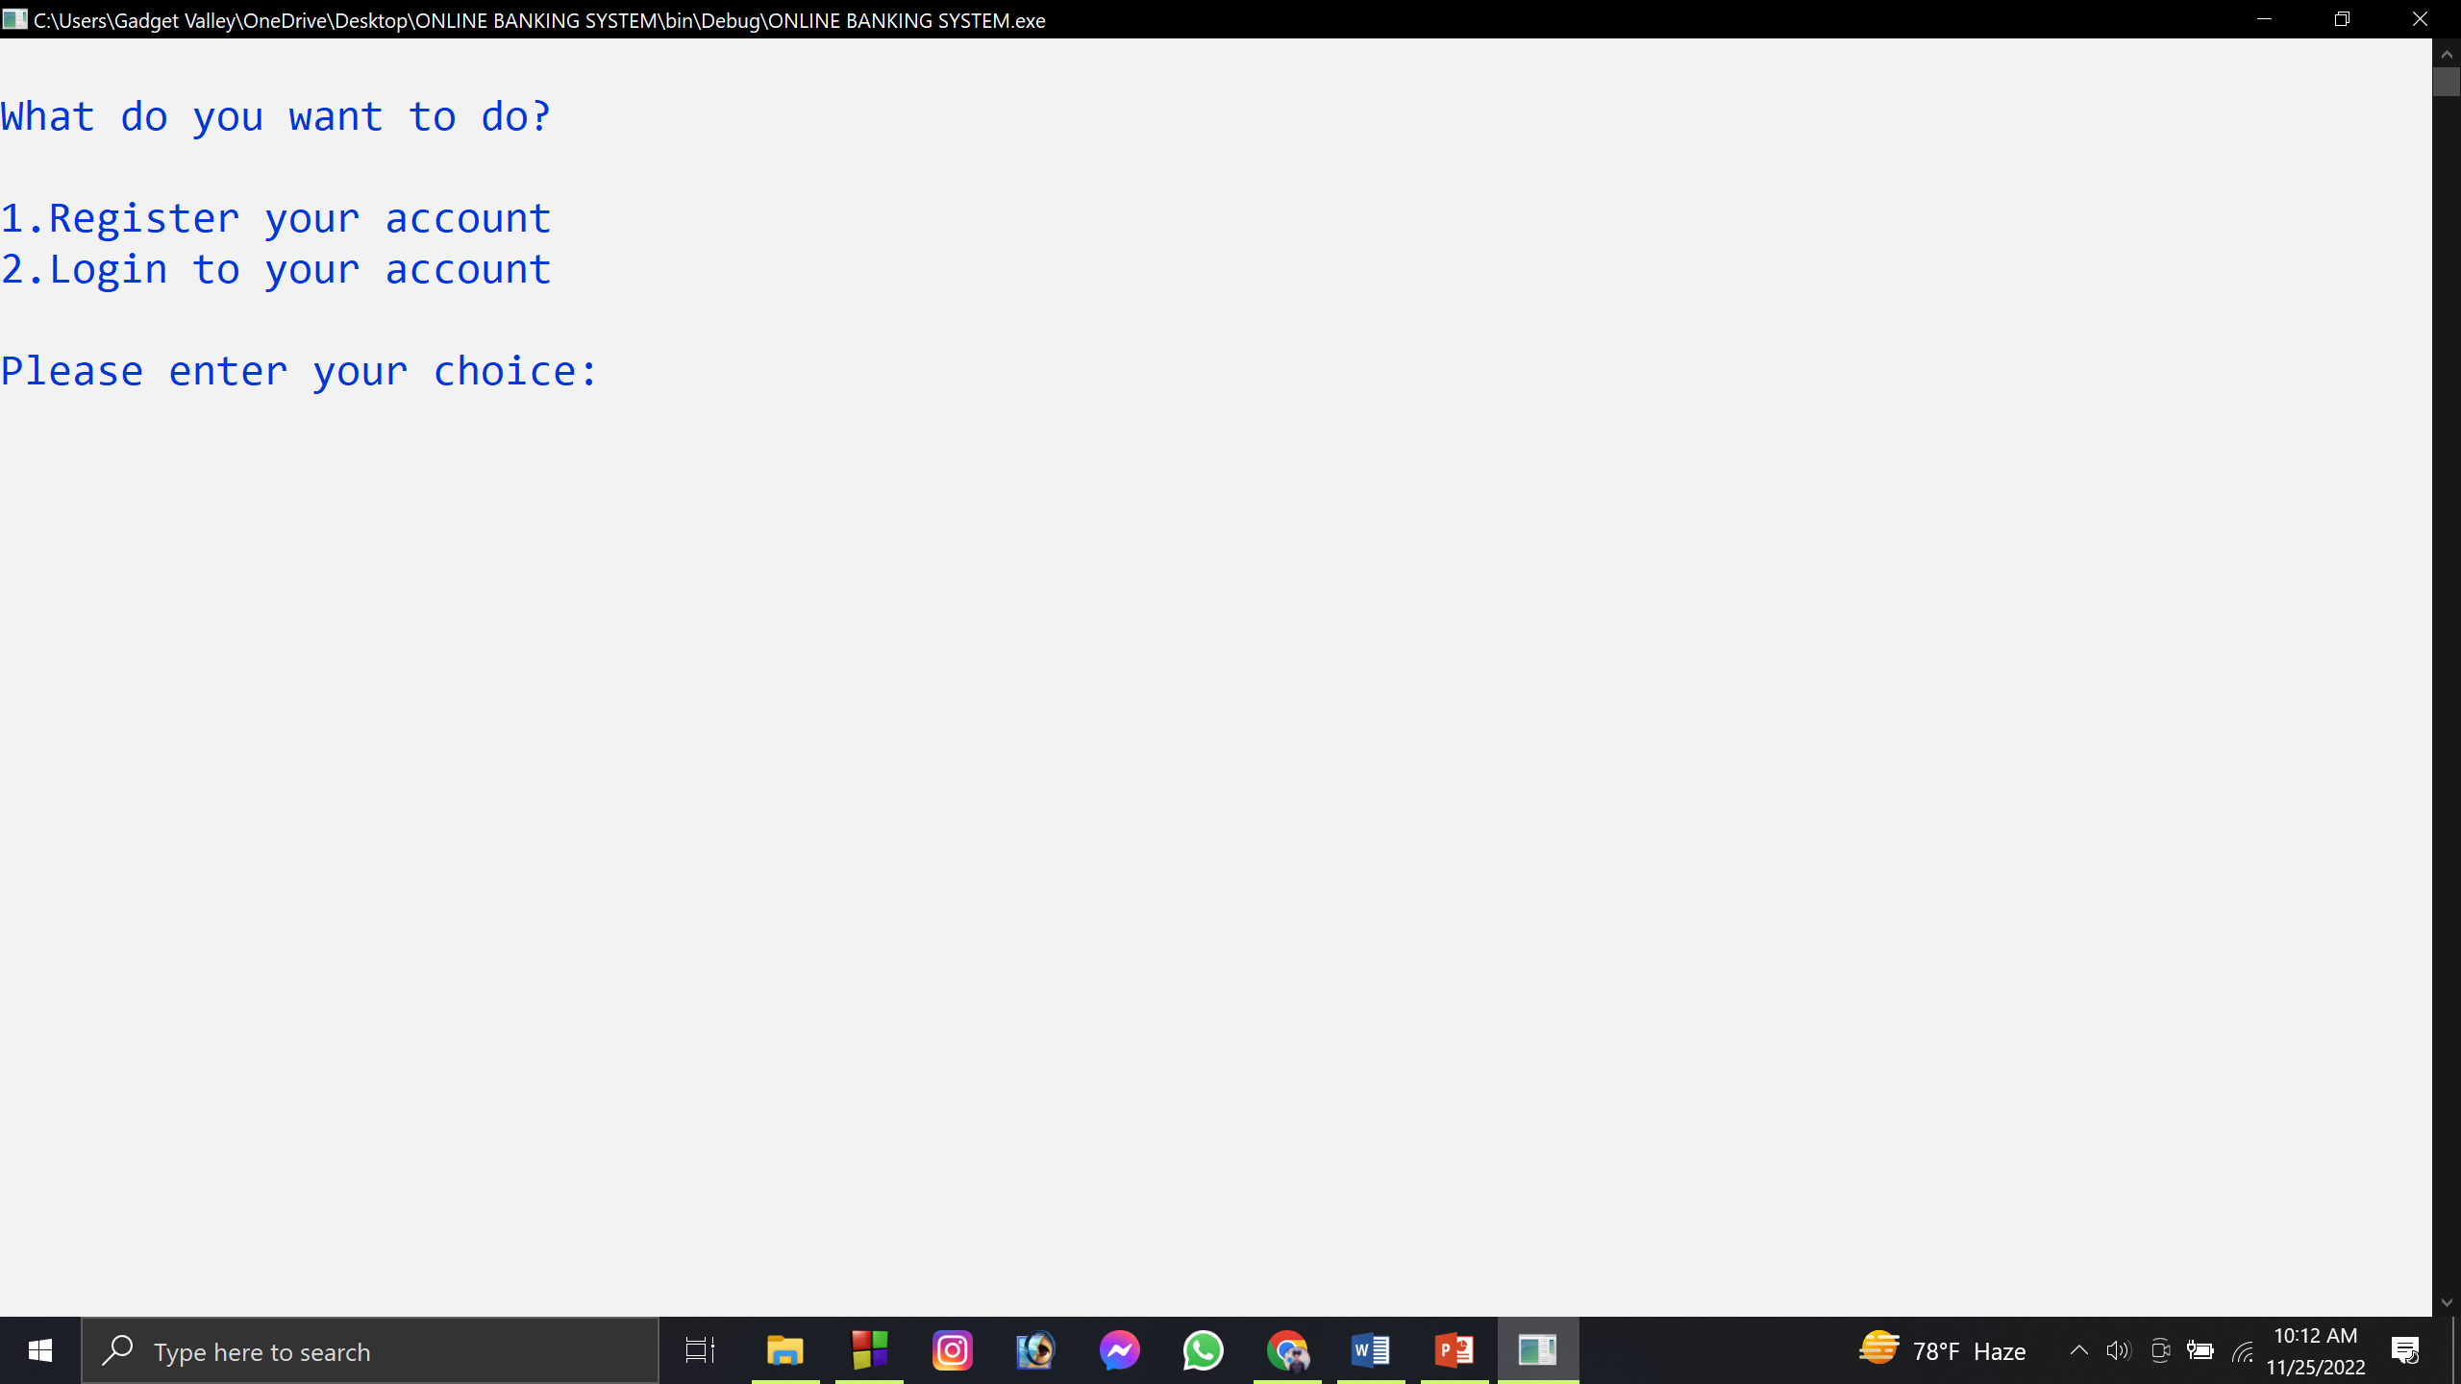

**Fig-2**

**Fig-2:** Here we have two options, if we want to go further either we have to registration a new account or we already have an account then we can login here.

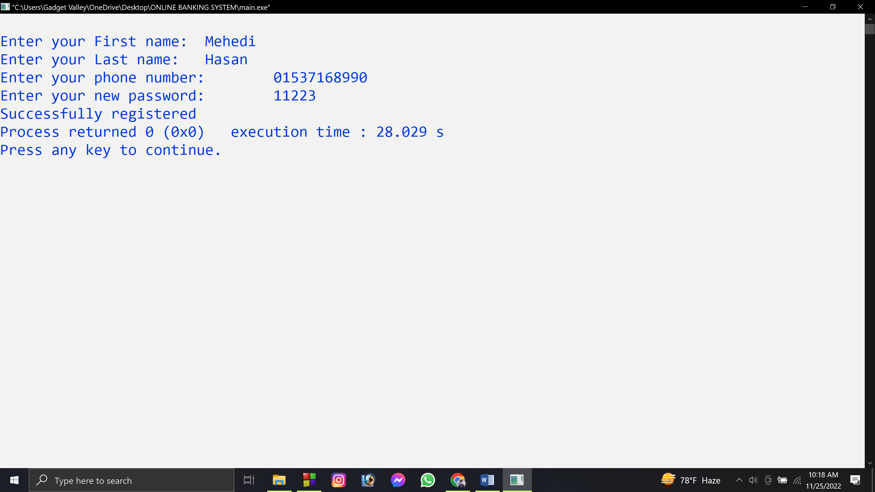

**Fig-3**

**Fig-3:** We are going to create a new account, so we have chosen option1. For completing registration, we need fill up our information and it will be successfully done. However, phone number must be 11 digits and password must be 5 digits otherwise it will not work then program will end with warning message.

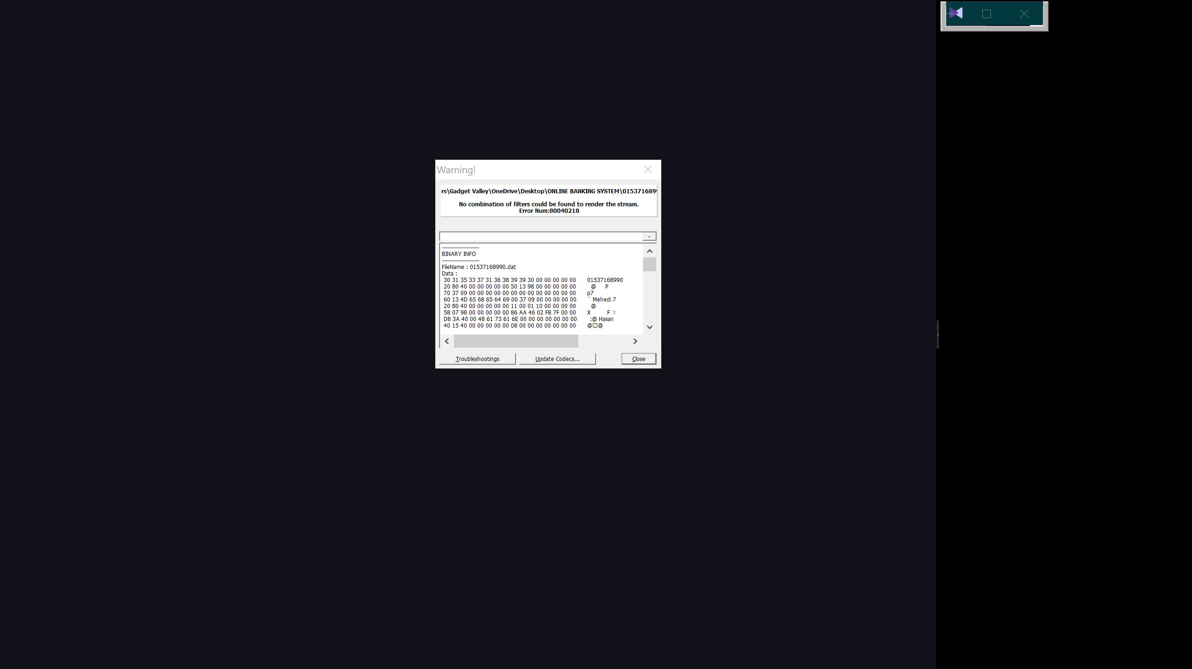

**Fig-4**

**Fig-4:** When user completes their registration their data is saved in .DAT or in Database. Later User data will be updated when they modify it. And also bank has access to it.



**Fig-5**

**Fig-5:** After completing registration then program will end and we have open again our application. Then again this time we have to choose option 2 for login and we can access our account.

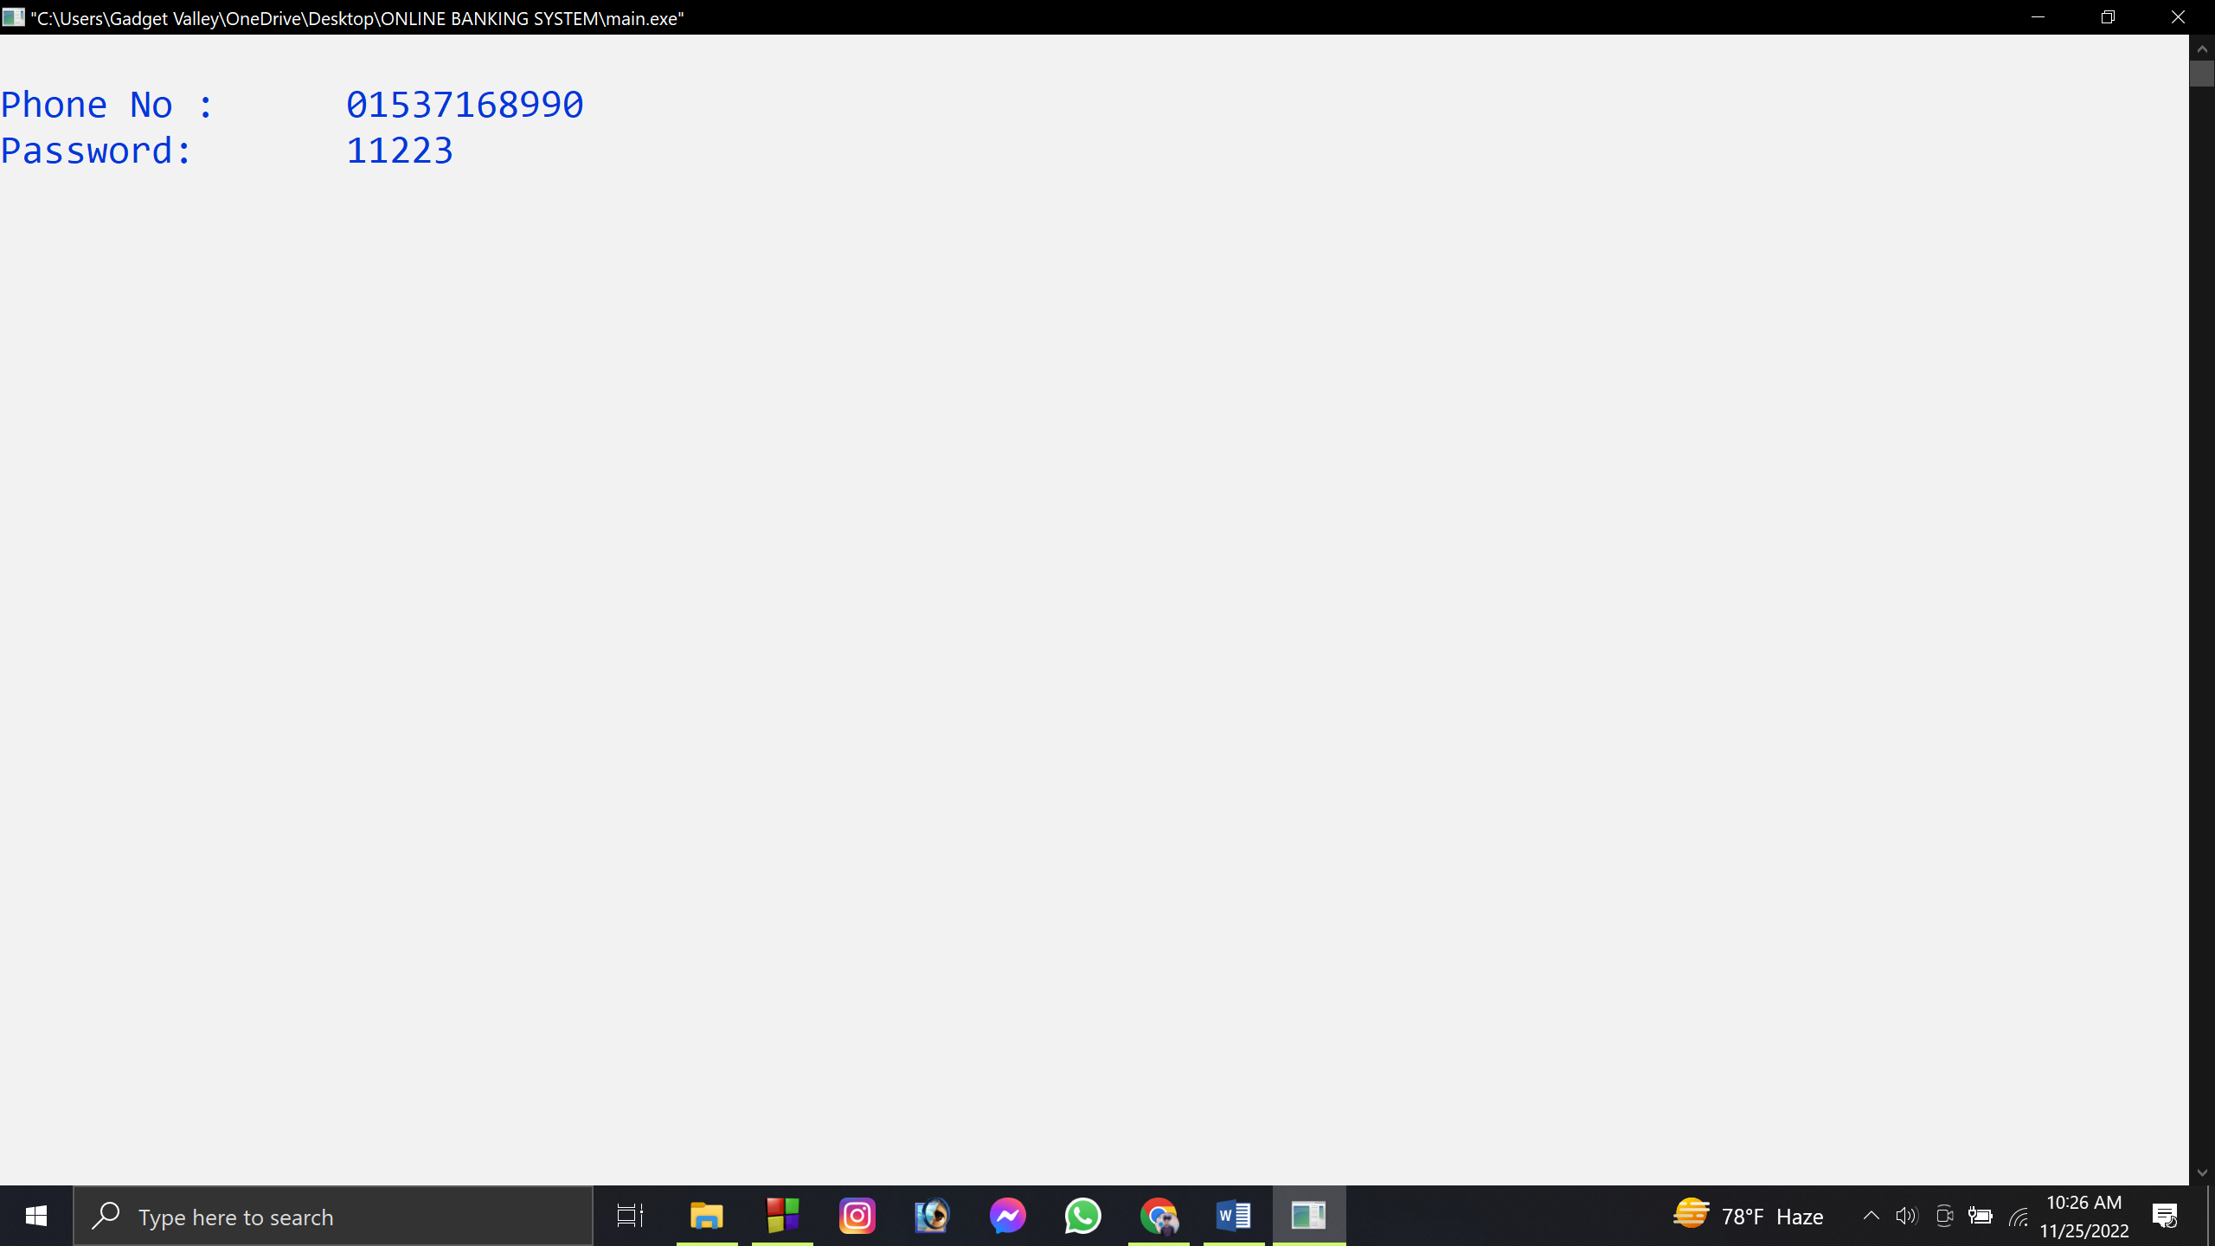

**Fig-6**

**Fig-6:** After choosing option 2 we will see this page. Here we have to insert our phone number and password that we registered. If password or phone number or both of them were wrong then code will end with a warning message.

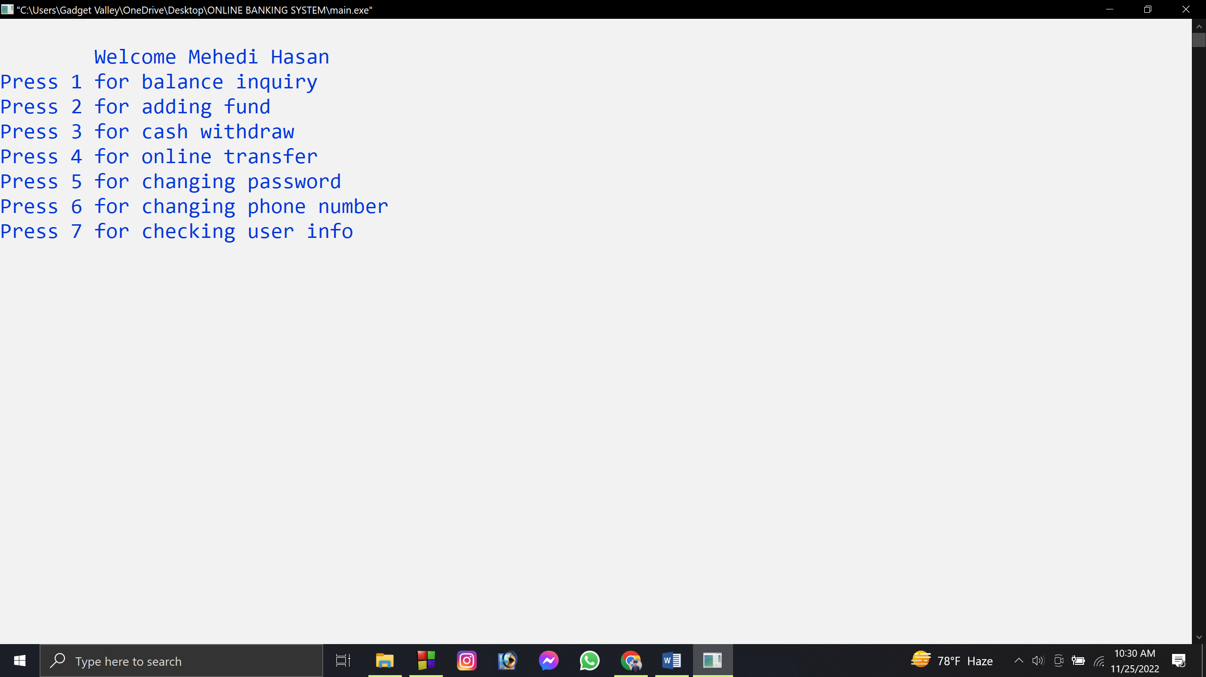

**Fig-7**

**Fig-7:** This is main menu where user can see their accessible feature.

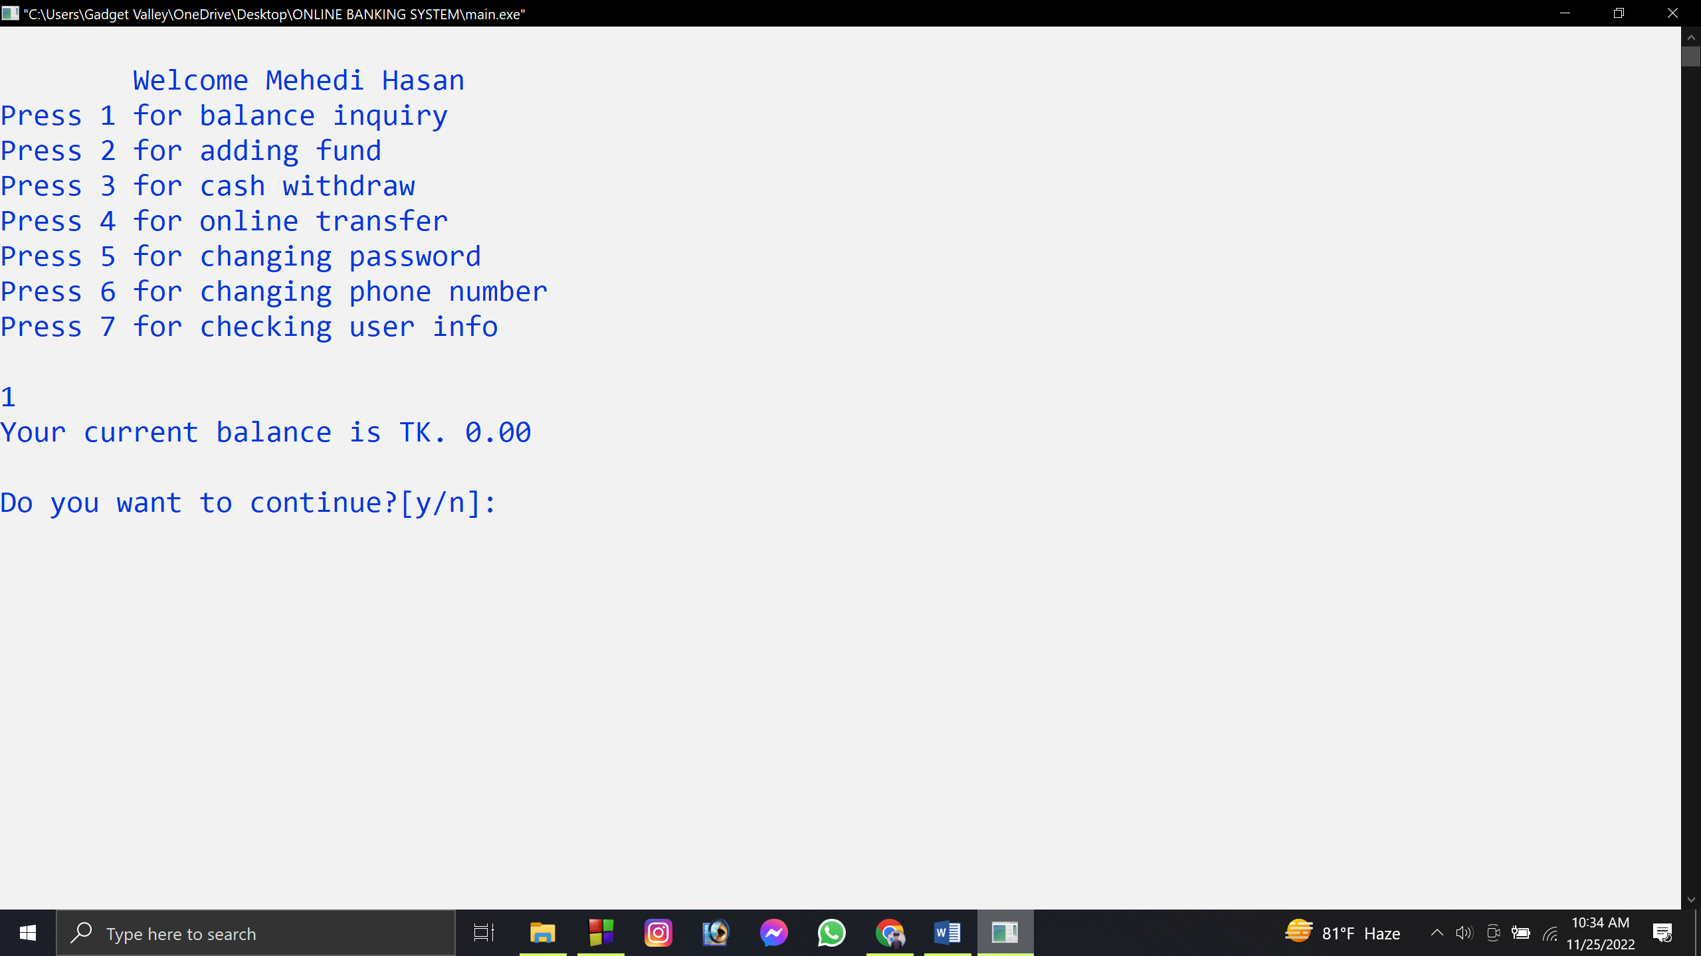

**Fig-8**

**Fig-8:** If user press 1 then user can see their balance on this account. And if user want to use another feature than user can press y or else n.

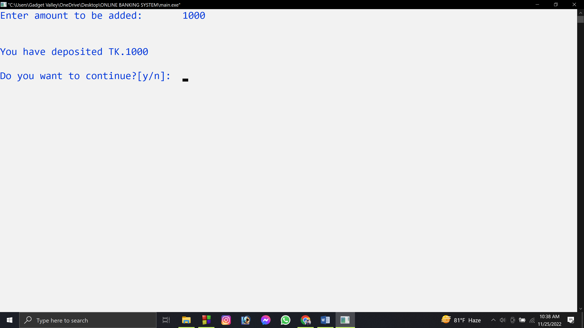

**Fig-9**

**Fig-9:** If user press 2 then user can add their fund/balance on this account. And if user want to use another feature than user can press y or else n.

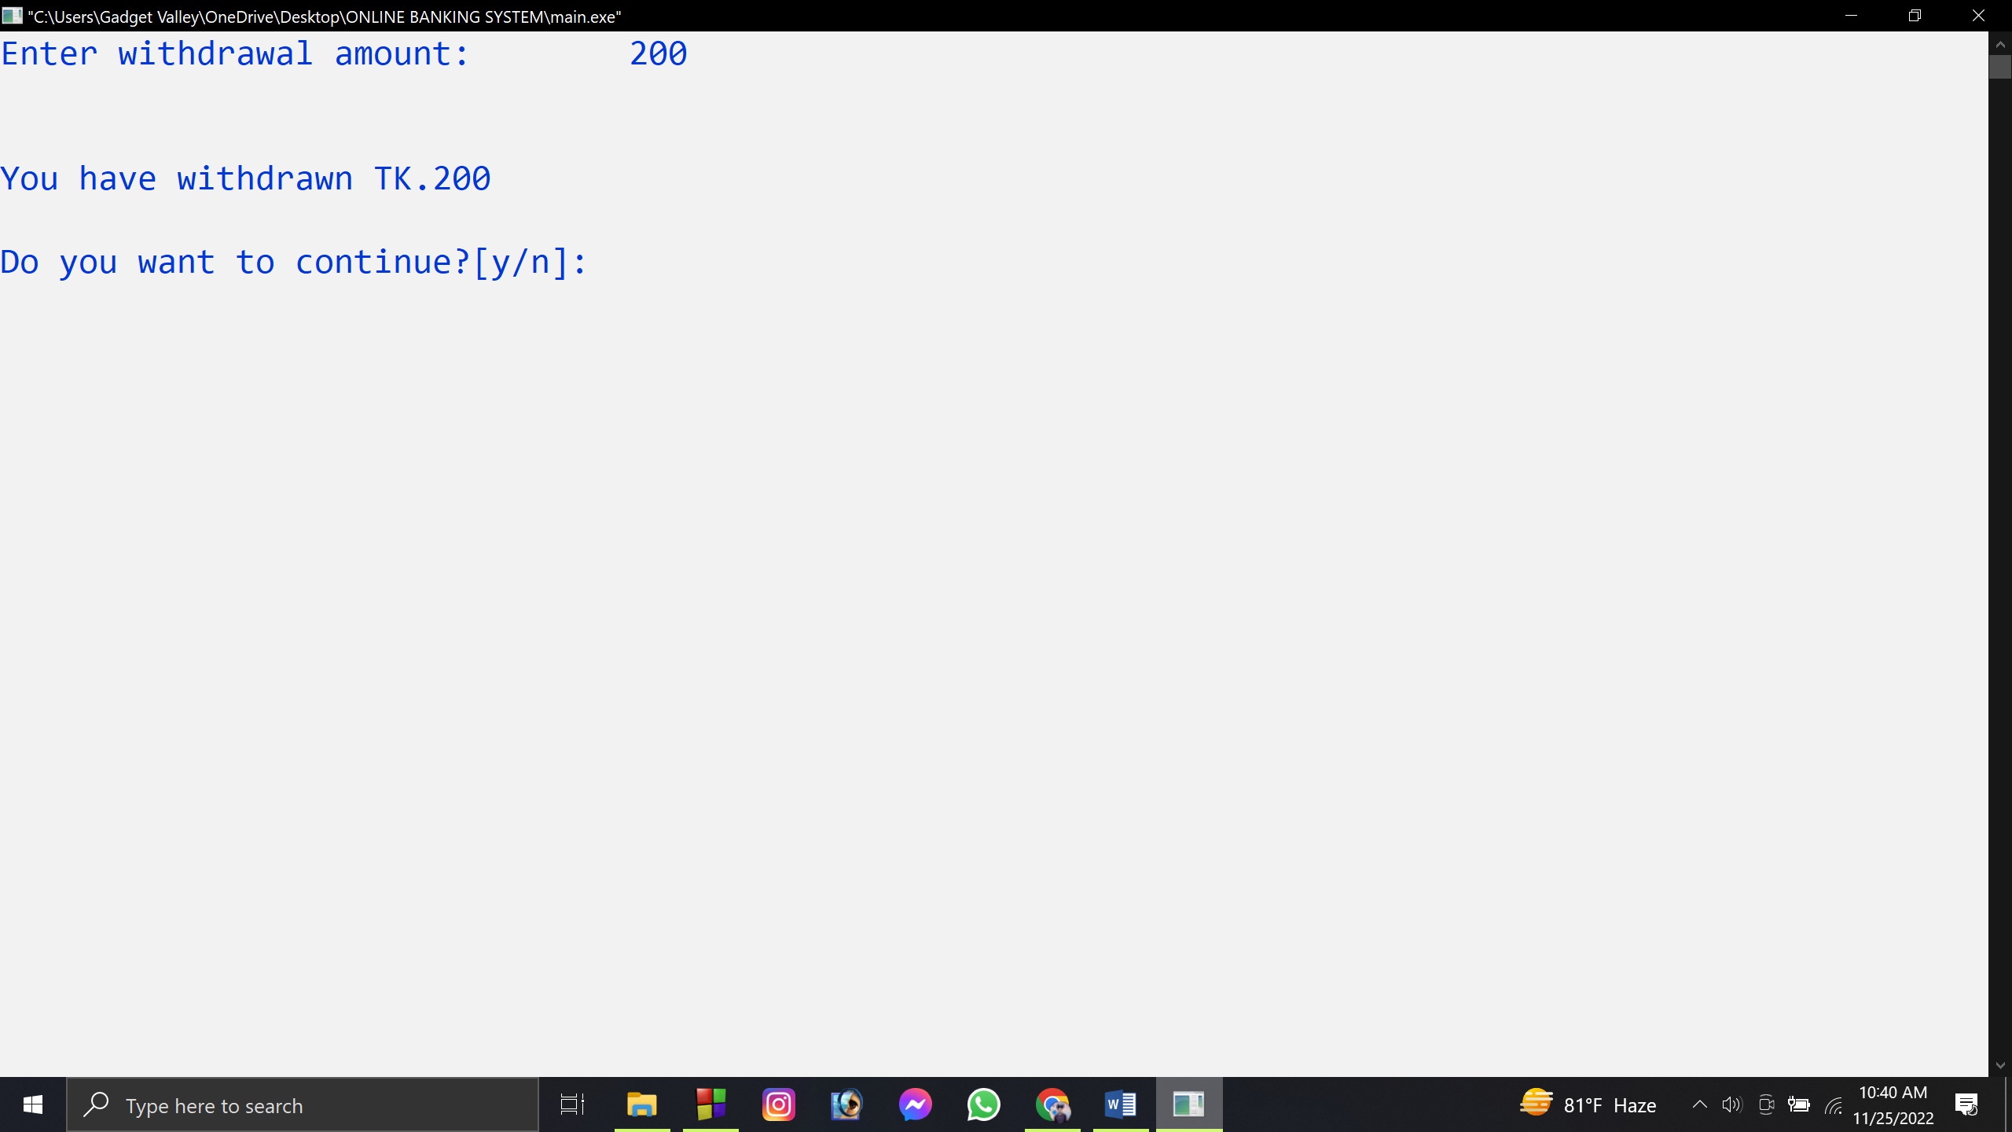

**Fig-10**

**Fig-10:** If user press 3 then user can cash out/ withdraw their fund/balance on this account. And if user want to use another feature than user can press y or else n.

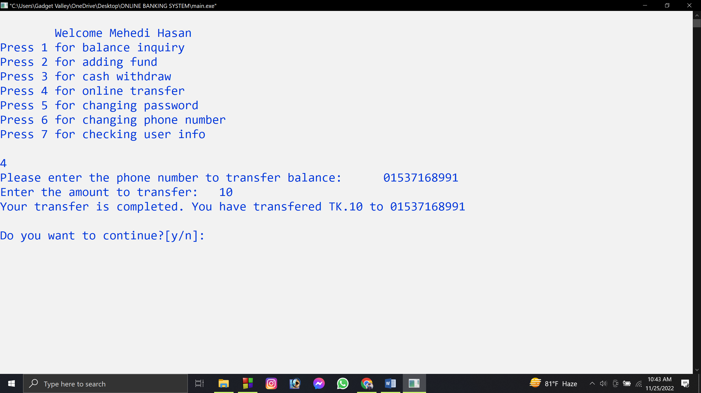

**Fig-11**

**Fig-11:** If user press 4 then user can send-money/online transfer their fund/balance in another existing account on this application. First they have to insert the number they want to send money and the amount. It will be successfully done. And if user want to use another feature than user can press y or else n.

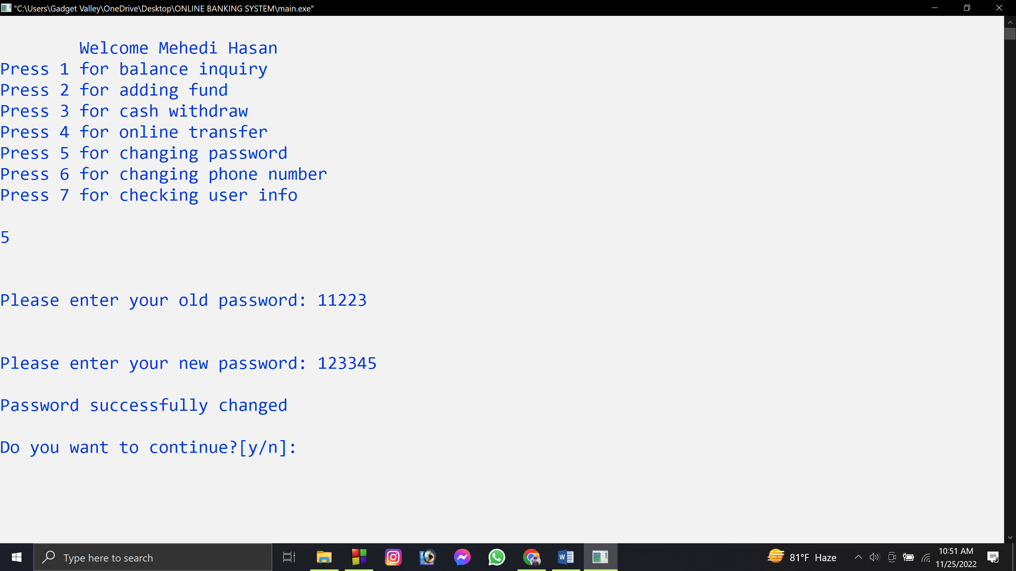

**Fig-12**

**Fig-12:** If user press 5 then user can change their password on this account. User has to insert old password then new password. If old password is wrong then there will be warning message. If user wants to continue the user can press y otherwise n.

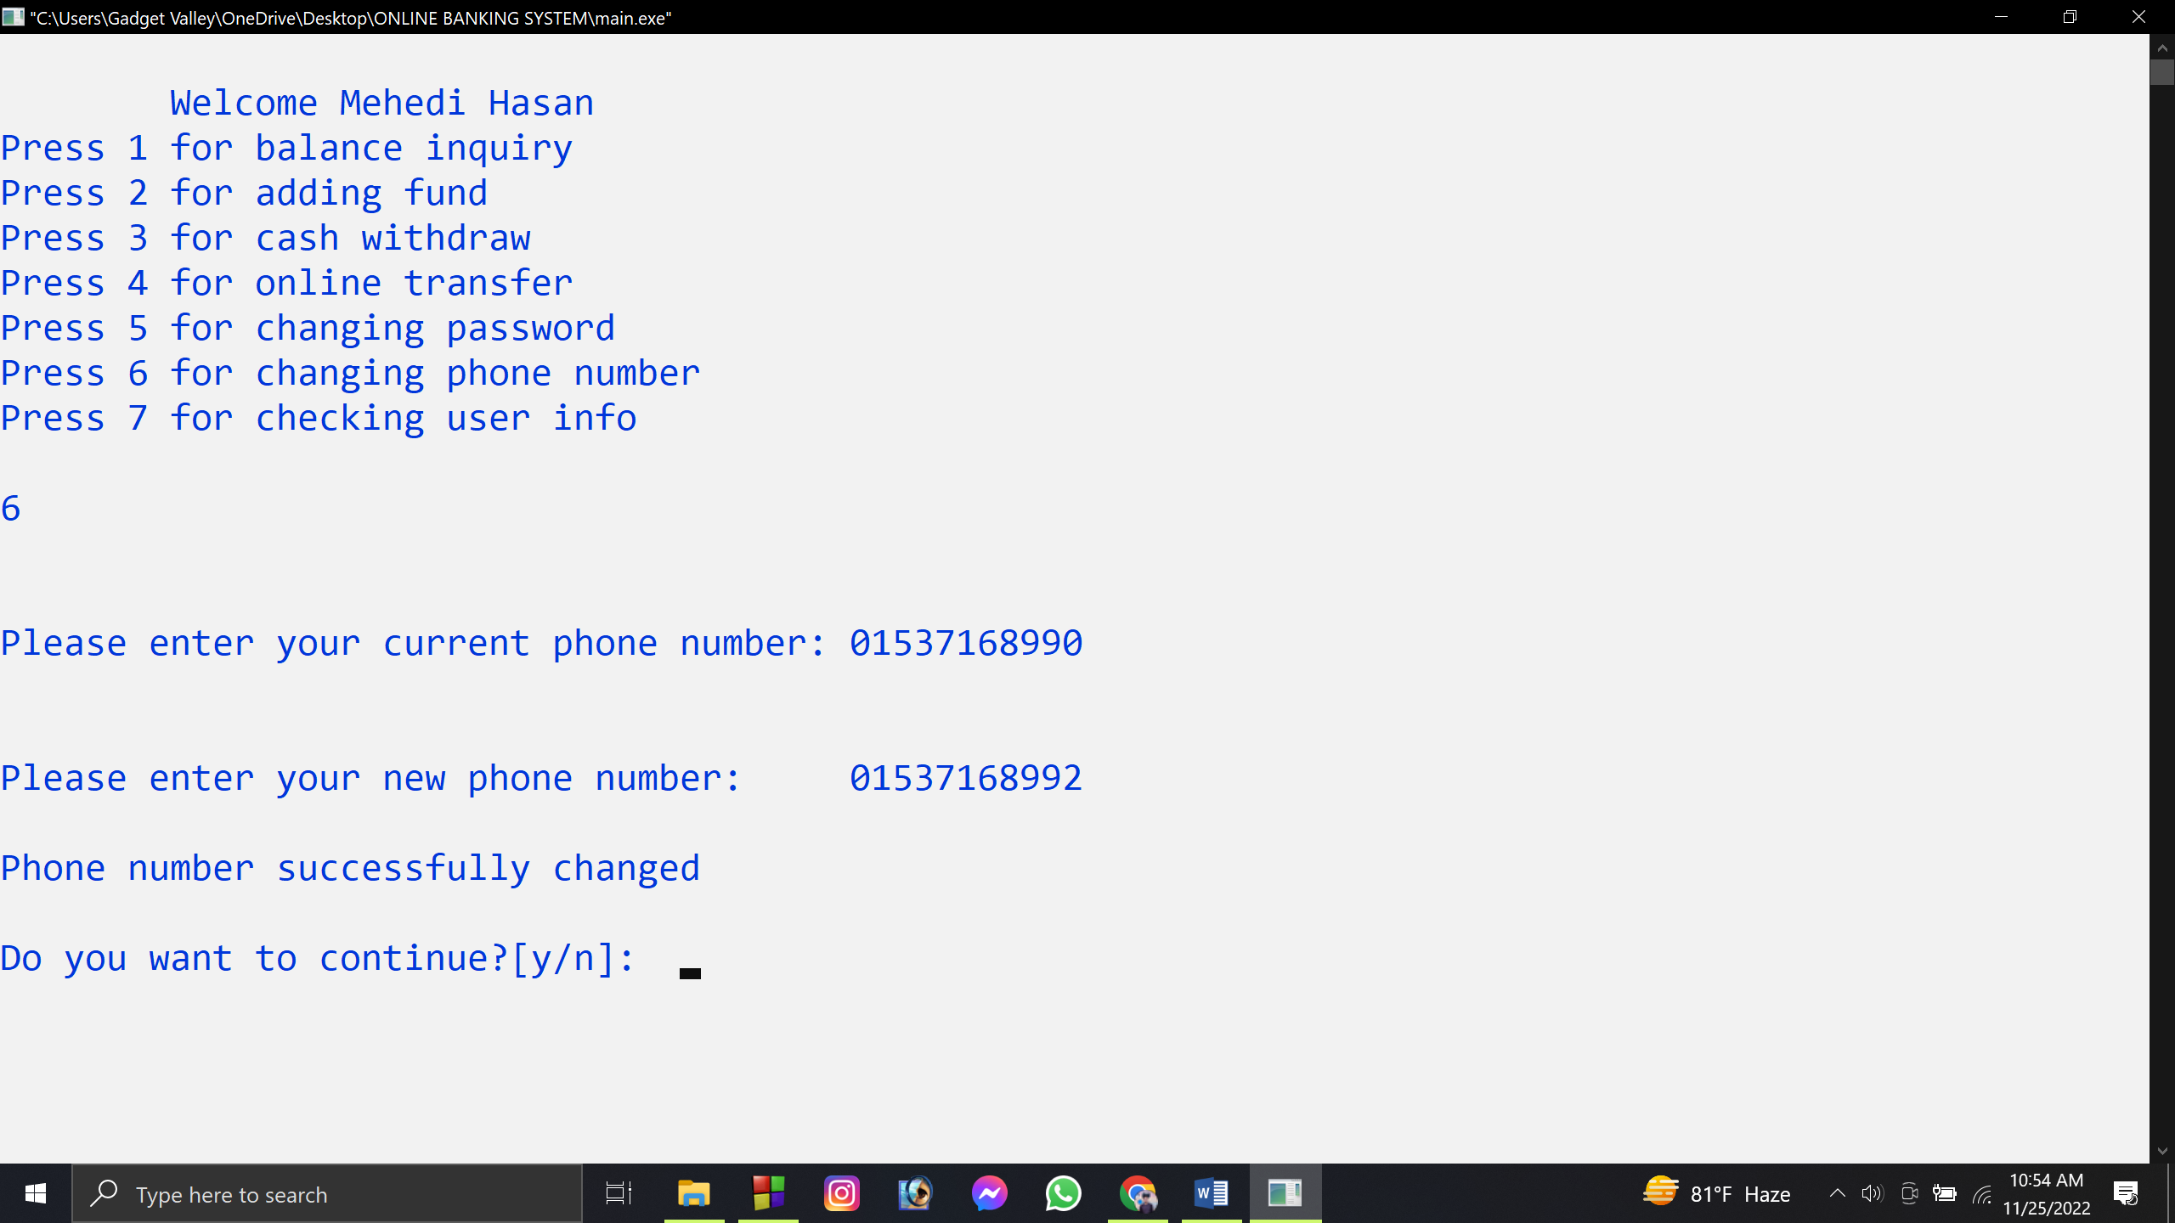

**Fig-13**

**Fig-13:** If user press 6 then user can change their phone number/account number on this account. User has to insert current phone number then new phone number and also if old phone number was wrong then there will be warning message. And if user want to use another feature than user can press y or else n.

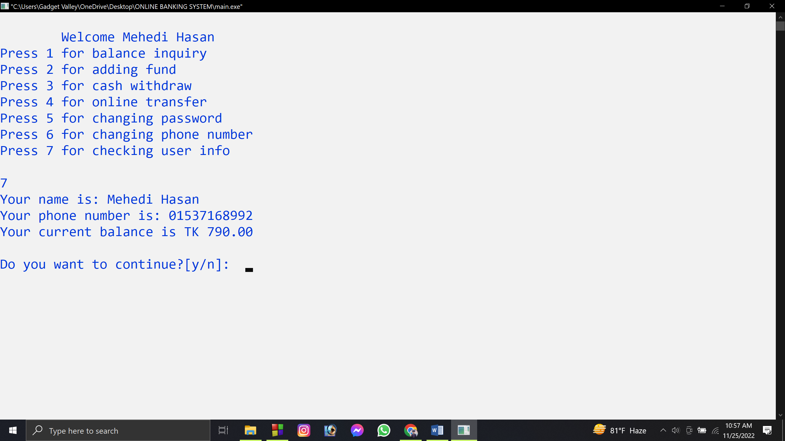

**Fig-14**

**Fig-14:** If user press 7 then user can check their Information on this account such as name, phone number, current balance. And if user want to use another feature than user can press y or else n.

**Chapter- 5: Conclusion**

**5.1 Limitations**

For our work we used updated software and technologies. Still our proposed system may face some drawbacks and some are listed below:

* Our system can’t verify user information.
* Our system has the feature for fund deposit & withdraw but it can be done by user. So, we need another software for agent banking or bank workers for adding fund or withdraw fund.
* Our system can’t show user transaction summary.

**5.2 Future works**

We have many user friendly features and modification for the project in the near future. Which we couldn’t done this time due to lack of manpower & fund. We can achieve more accuracy by fixing the limitations of our program. Some works which we can improve are given below:

* We will add a pay bill feature. In this feature user can pay bill to various company and services.
* We will add a mobile recharge feature that will help user easily recharge balance in their phone number by few clicks.
* We are planning to add a feature to add & send funds from others bank. Using this feature user can add or send money to other banks and also transfer money from other bank to their account in our system.
* Currently we cannot show the transaction summary which we are planning to add in the future.

**5.3 Conclusion**

Internet banking is changing the banking industry and is having the major effects on banking relationships. Banking is now no longer confined to the traditional brick and mortar branches, where one has to be at the branch in person, to withdraw cash or deposit a cheque or request a statement of accounts. In a country like Bangladesh, there is need for providing better and customized services to the customers. Banks must be concerned about the attitude of customer with regard to acceptance of internet banking.